Meditation Sessions

During meditation in most cases we see decrease of Sputnik signal, but in some cases, we record increase.

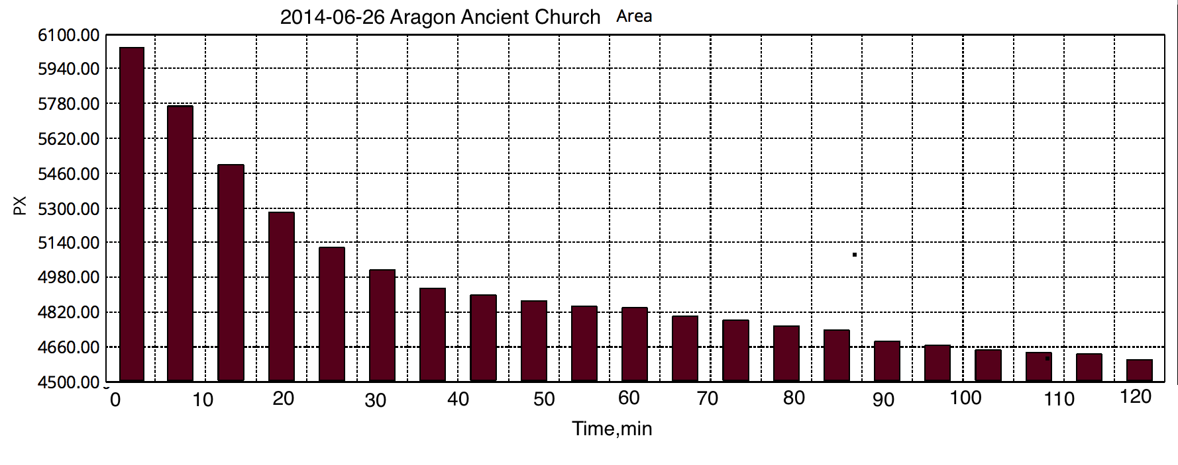
Effect of collective meditation.

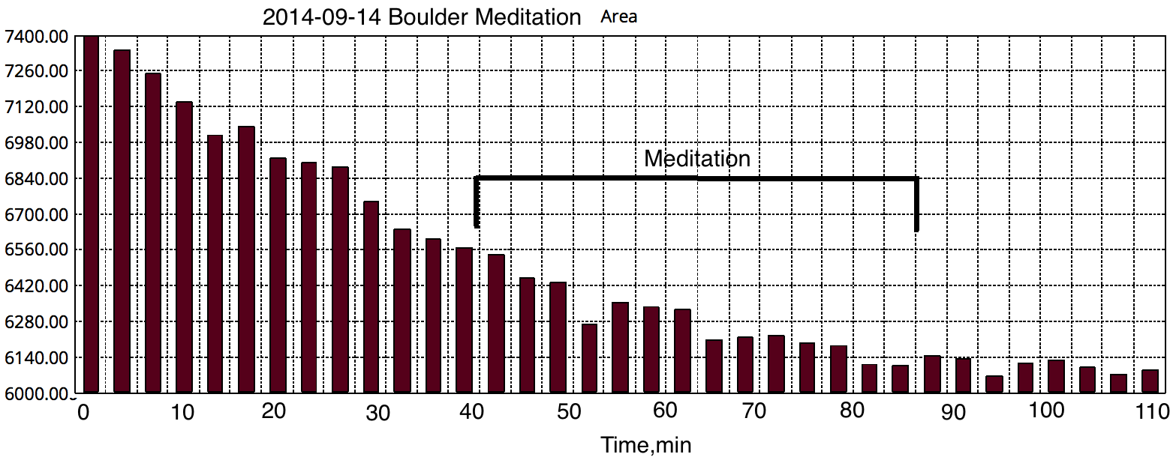
Effect of collective meditation.

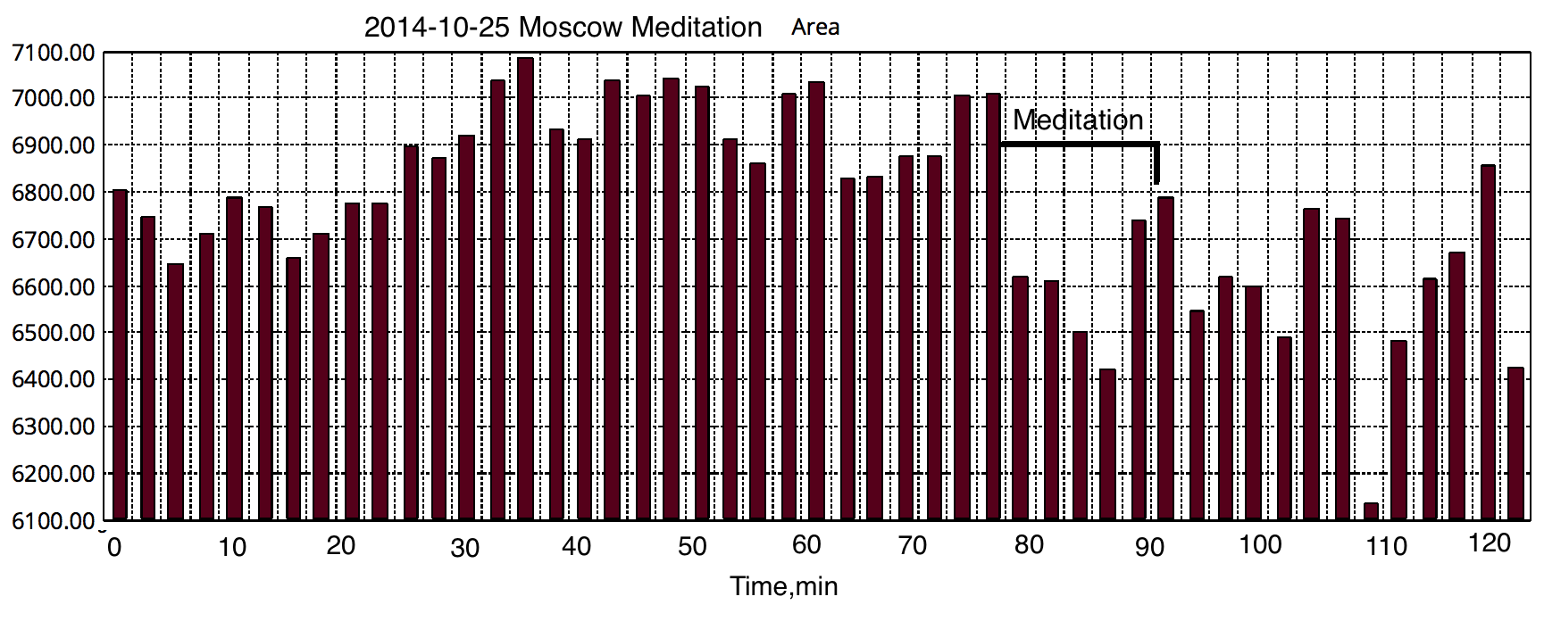
Effect of collective meditation.

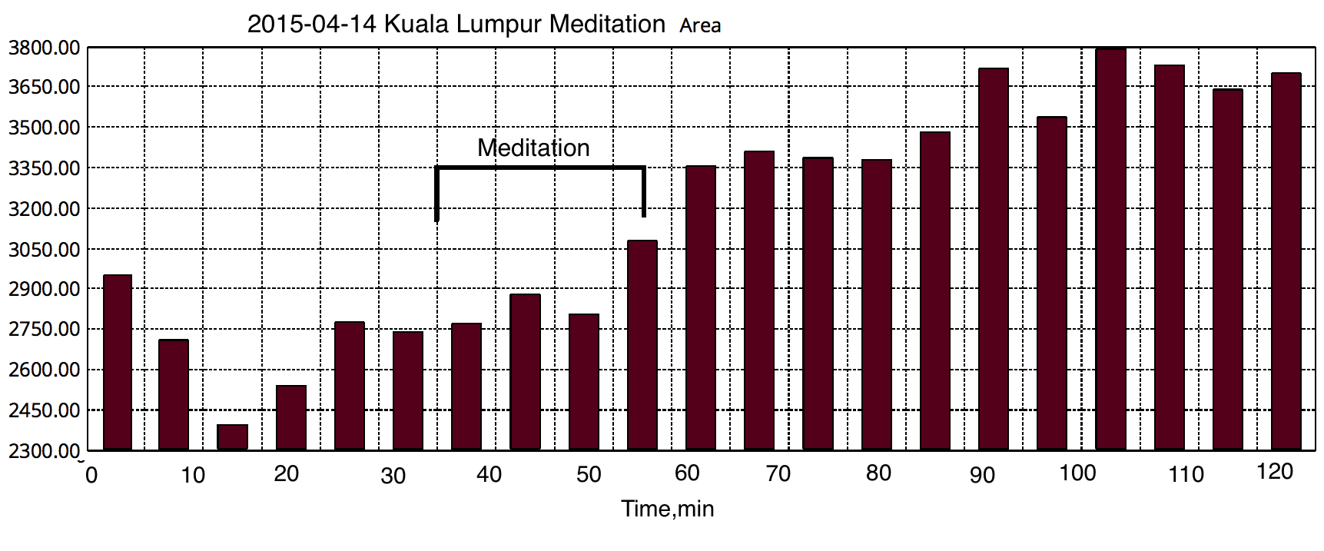
Increase of signal.

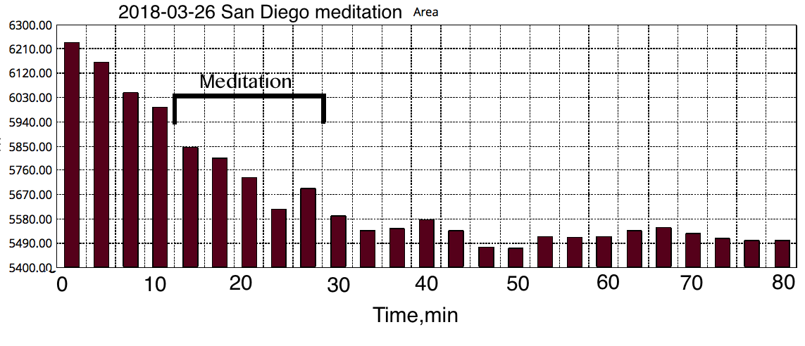
Effect of collective meditation.

